HARDWARE TEST PROCEDURE OF ENCODER BASED FOC USING MATLAB AND dsPIC33CK LVMC

1. EQUIPMENT / HARDWARE TOOLS REQUIRED:

Hardware Tools required for testing are:

1. dsPIC33CK Low Voltage Motor Control (LVMC) Development Board (DM330031)
2. 24V Power Supply (AC002013)
3. 24V 3-Phase Brushless DC Permanent Magnet Motor Hurst motor (AC300022)
4. SOFTWARE TO BE INSTALLED:

Software Tools required for testing are:

1. MPLAB X IDE and IPE (v5.50 or later)
2. XC16 compiler (v1.70 or later)
3. MATLAB R2020b (or later)
4. Important MATLAB Add-on Packages required

* Simulink
* MPLAB Device blocks for Simulink (v3.50.13 or later)
* Motor Control Blockset
* Embedded Coder
* Fixed-Point Designer

1. HARDWARE SETUP:

The hardware setup procedure is described below:

1. Connect the three phase wires from the motor to PHA, PHB, and PHC terminals of connector J14 and encoder wires from the motor to +5V, GND, QEA and QEB terminals of connector J8 (in the same order as shown in the picture) provided on the dsPIC33CK LVMC board.

|  |  |
| --- | --- |
|  |  |

Note: The phase and encoder connector sequency can be found in the Hardware Init block of the model, as shown below

1. Plug in the 24V power supply to connector J1 or J2 provided on the dsPIC33CK Low Voltage Motor Control Board.

1. The LVMC board has an on-board programmer ‘PICKIT™ On Board (PKOBv4)”, which can be used for programming or debugging dsPIC33CK256MP508 device used for controlling the motor. To use on-board programmer, connect a micro USB cable between Host PC and Connector J13 provided on the dsPIC33CK LVMC Board.

1. Alternatively, connect the Microchip MPLAB PICkit 4 In-Circuit Debugger to the Connector J10 of the dsPIC33CK LVMC Board as shown below and to the Host PC used for programming the device. Ensure that PICkit 4 is connected in correct orientation.

|  |  |
| --- | --- |
|  |  |

1. MATLAB model SETUP and Program the dEVICE:

Follow the steps to setup up MATAB Simulink model and Program the dsPIC:

1. Launch MATLAB version specified under the section **“****2. SOFTWARE TO BE INSTALLED****”**
2. Open the folder in which encoder based FOC Simulink files has been saved.

1. Double click on the .m file, then file will open on the screen. This .m file contains the configuration parameters for the motor (and board) and presently set for Hurst 300 (AC300022). These configuration need to be changed, in case a different motor is selected.Run the file using “**Run**” icon and wait till all variables gets loaded on the ‘**Workspace**’ tab.

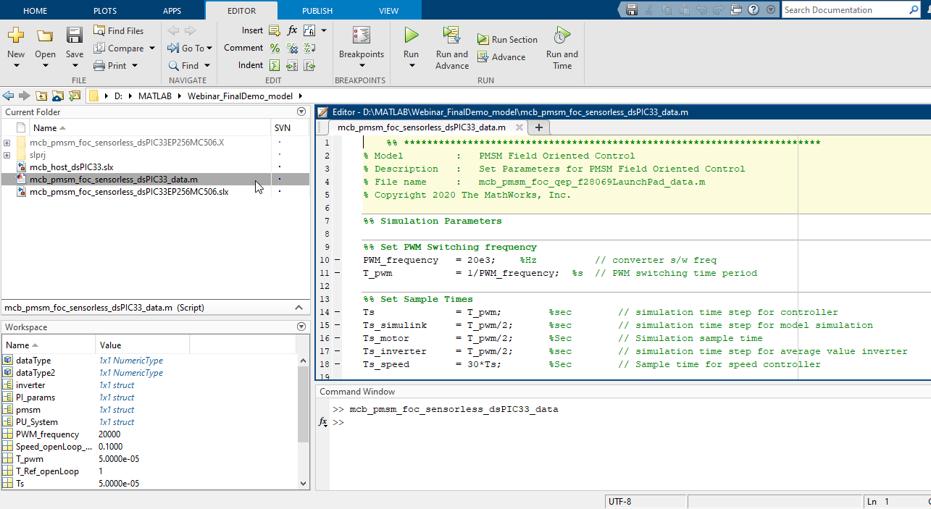

1. Double click on the .slx file to open the Simulink model.

1. This opens the Simulink model window as shown in the below figure. To observe the simulation output, run the simulation and plot the required motor parameters.

1. To generate the code from the Simulink model and run the real permanent magnet synchronous motor, go to Microchip tab and enable the tabs shown in the figure below. This will select the Programmer and code will flashed to microcontroller after building.

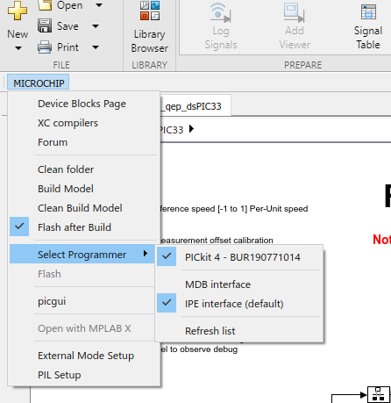

1. Click on the ‘**Apps**’ tab on the menu bar and open ‘**Embedded Code**’.

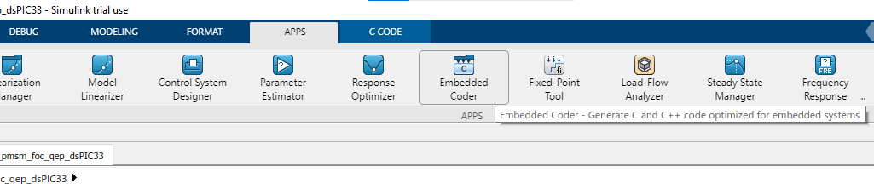

1. The ‘**C Code**’ tab will appear on the menu bar, then click on ‘**Build**’ to build, generate and flash the code.

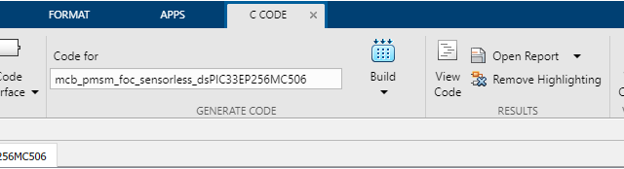

1. The code starts generating and ‘**Diagnostics Viewer’** window will open.
2. After code generation the code will be flashed to dsPIC through the programmer and ‘**Operation Succeeded**’ message will be seen on the ‘**Diagnostics Viewer’.**

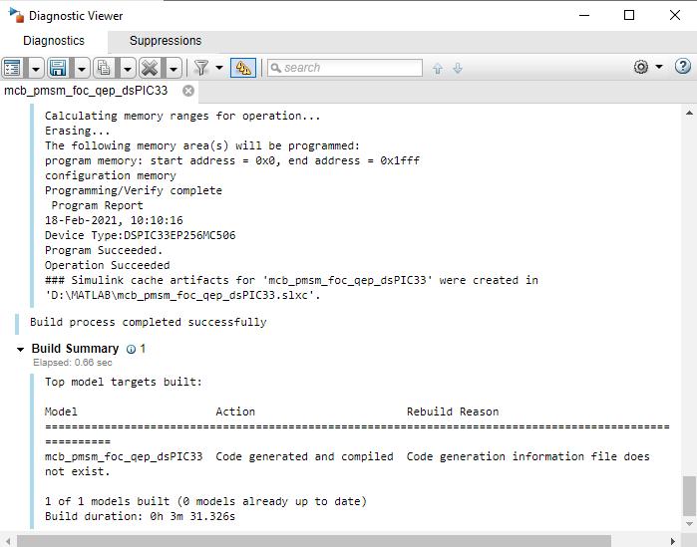

1. VERIFICATION Test:

* Verify the debug LED’s ‘**LD10 and LD11**’ are blinking, this confirms that the dsPIC device has successfully programmed.
* The ‘POT’ on the LVMC board is configured the vary motor speed from -1 to 1 per unit of rated speed. Vary the POT from mid-point to either direction in order to spin the motor from minimum speed to maximum speed and verify that the generated code working fine.